**SOFTWARE ENGINEERING LAB**



**Session 2022 – 2026**

**Submitted by:**

Raveeha Mohsin 2022-CS-149

**Supervised by:**

Mr. Atif

Ms. Maryam

Department of Computer Science

**University of Engineering and Technology**

**Lahore Pakistan**

Contents

1 Data Flow Diagrams 3

1.1 Basic DFD Level 0 for AI Career Path Navigator: 3

1.2 Extended DFD Level 0 with Detailed Data Flows: 3

1.3 DFD Level 0 with Additional Features Like Chatbot & Notifications: 4

2 DFD Level 1 for AI Career Path Navigator 4

3 DFD Level 2 for AI Career Path Navigator 5

3.1 Student DFD Level 2 5

3.2 Counselor DFD Level 2 5

3.3 Admin DFD Level 2 6

4 Sequence Diagram for AI Career Path Navigator 7

5 UML Diagram for AI Career Path Navigator 8

6 Class Diagram for AI Career Path Navigator 9

7 Activity Diagram for AI Career Path Navigator 10

8 Decision Tables 11

8.1 Decision Table 1: User Login 11

8.2 Decision Table 2: Career Recommendation Generation 11

8.3 Decision Table 3: Meeting Scheduling 11

9 Decision Tree 12

9.1 Profile Completion 12

12

9.2 User Login Decision Tree 12

9.3 Meeting Scheduling Decision Tree 13

9.4 Career Path Selection Decision Tree 13

9.5 Feedback Submission Decision Tree 14

10 Use Cases 15

10.1 User Login Use Case Diagram 15

10.2 Career Recommendation Generation Use Case Diagram 16

10.3 Meeting Scheduling Use Case Diagram 17

10.4 Feedback Submission Use Case Diagram 18

# Data Flow Diagrams

## ****Basic DFD Level 0**** for AI Career Path Navigator:

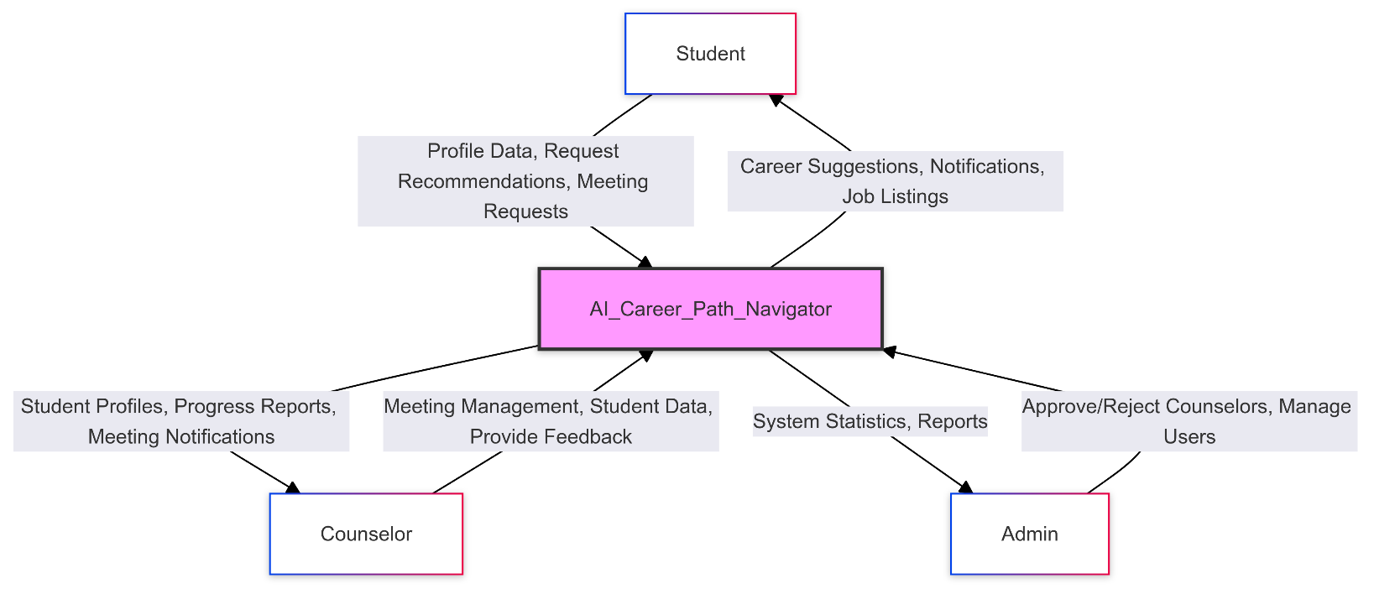

## ****Extended DFD Level 0**** with Detailed Data Flows:

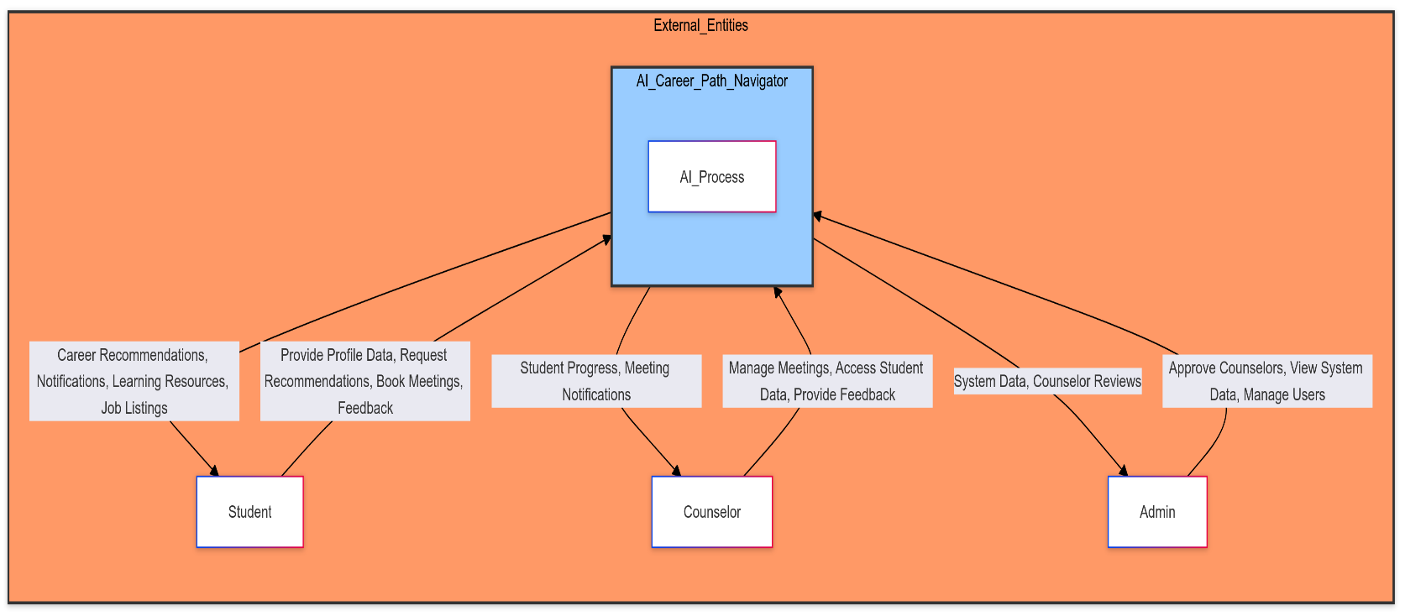

## ****DFD Level 0 with Additional Features Like Chatbot & Notifications****:

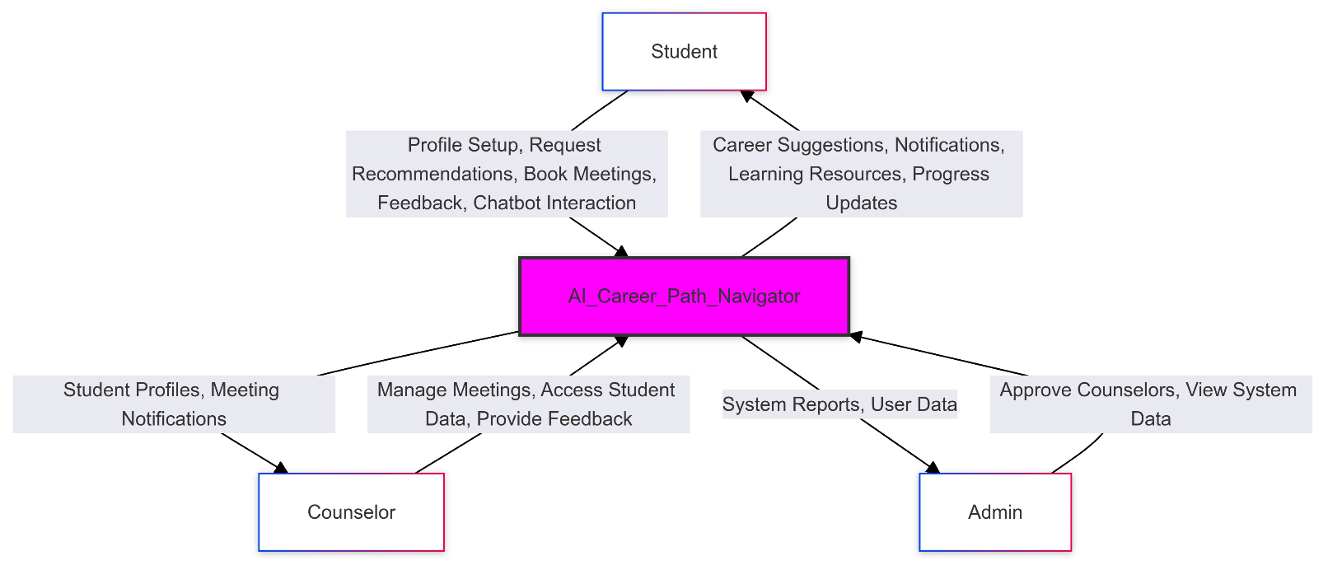

# DFD Level 1 for AI Career Path Navigator

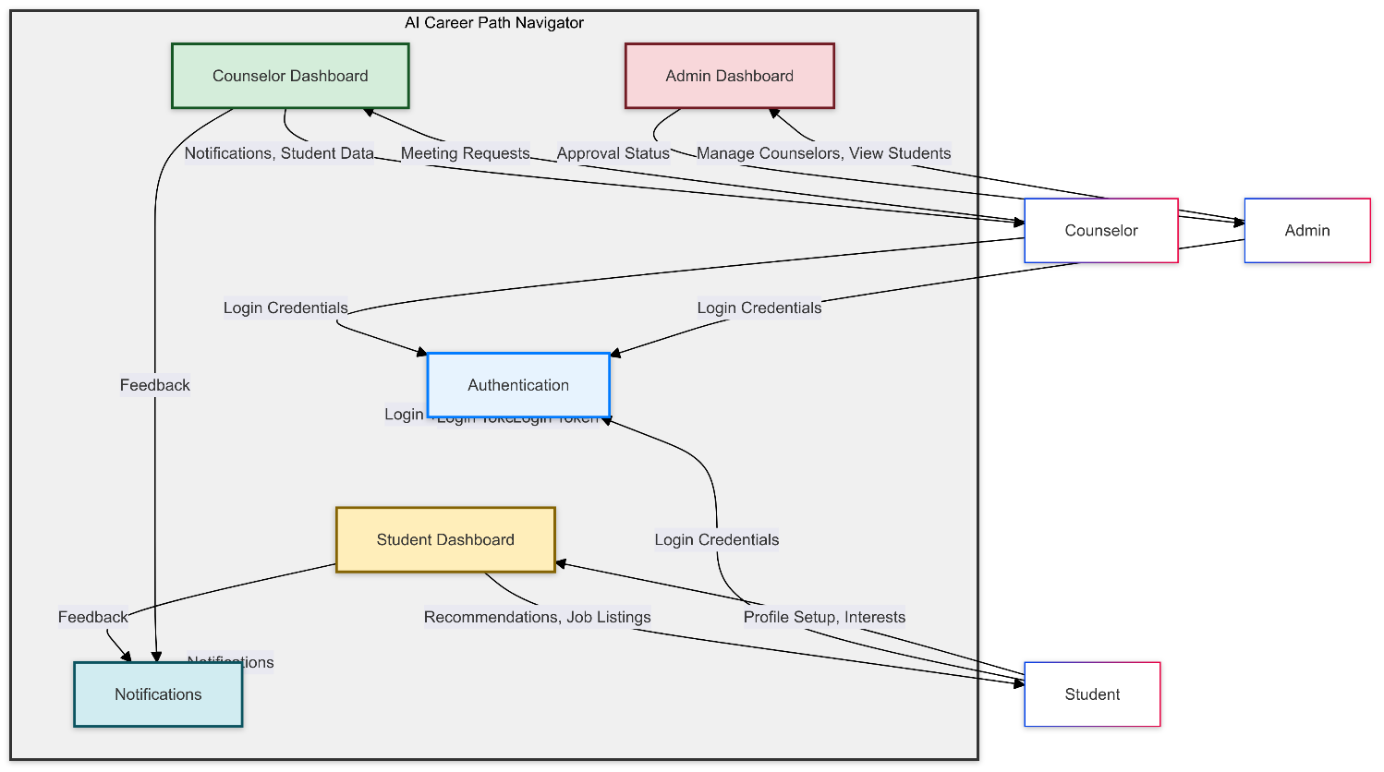

# DFD Level 2 for AI Career Path Navigator

## Student DFD Level 2

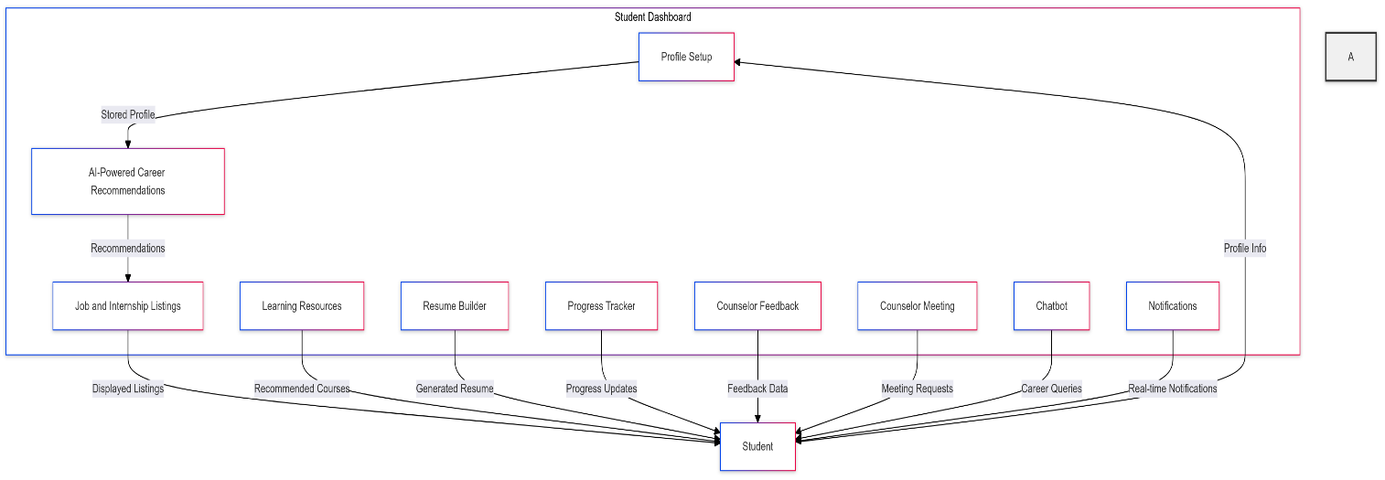

## Counselor DFD Level 2

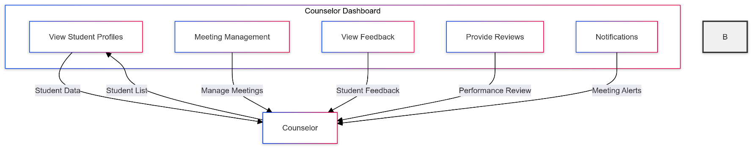

## Admin DFD Level 2

# Sequence Diagram for AI Career Path Navigator

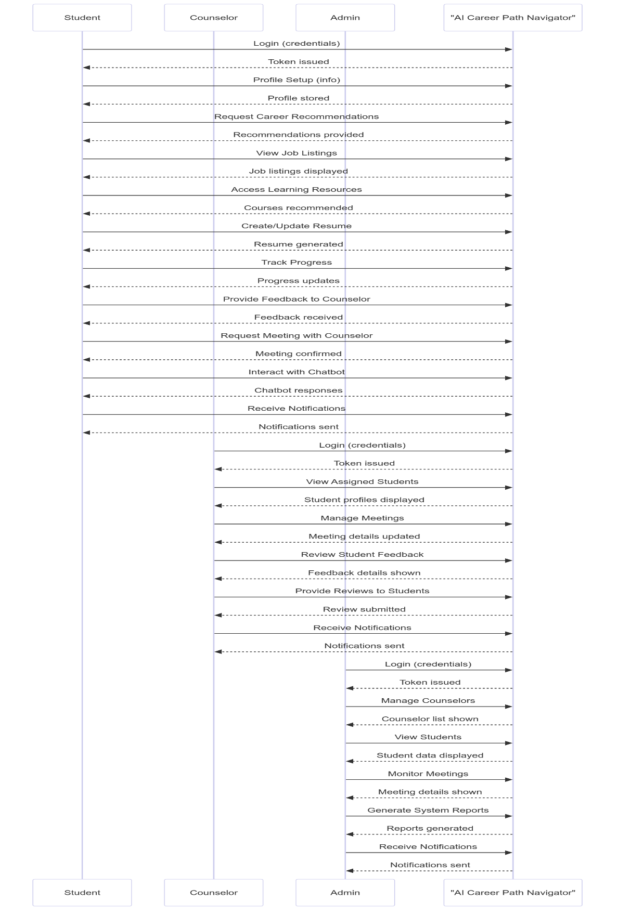

# UML Diagram for AI Career Path Navigator

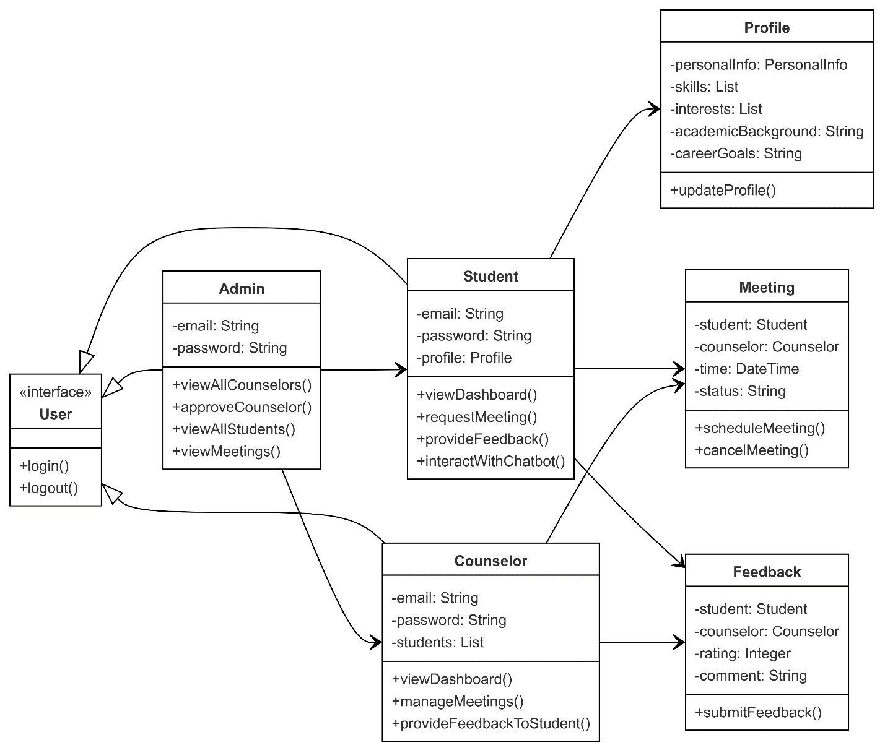

# Class Diagram for AI Career Path Navigator

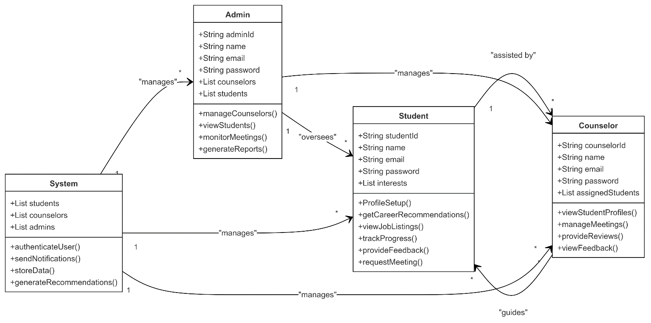

# Activity Diagram for AI Career Path Navigator

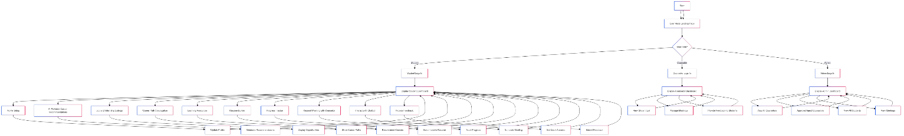

# Decision Tables

## Decision Table 1: User Login

|  |  |  |  |
| --- | --- | --- | --- |
| Condition | Valid Credentials | Account Status | Action |
| User Inputs Credentials | Yes | Active | Allow access to dashboard |
| User Inputs Credentials | Yes | Inactive | Display account inactive message |
| User Inputs Credentials | No | Any | Display invalid credentials message |

## Decision Table 2: Career Recommendation Generation

|  |  |  |  |
| --- | --- | --- | --- |
| Condition | Profile Complete | User Preferences | Action |
| Profile Complete | Yes | Matched | Generate personalized recommendations |
| Profile Complete | Yes | Not Matched | Suggest updating preferences |
| Profile Complete | No | Any | Prompt to complete profile |

## Decision Table 3: Meeting Scheduling

|  |  |  |  |
| --- | --- | --- | --- |
| Condition | Payment Made | Meeting Time Available | Action |
| Payment Made | Yes | Yes | Confirm meeting scheduled |
| Payment Made | Yes | No | Notify user of time unavailability |
| Payment Not Made | Any | Any | Notify user to complete payment |

# Decision Tree

## Profile Completion

## 

## User Login Decision Tree

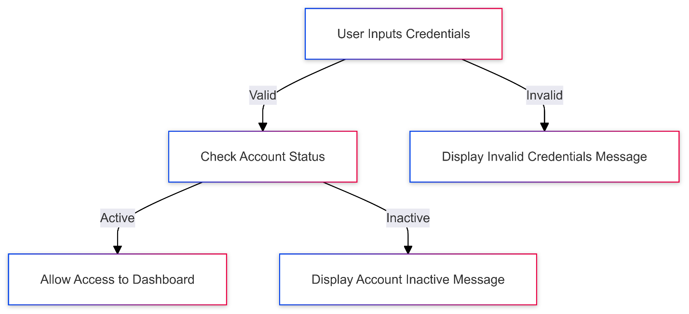

## ****Meeting Scheduling Decision Tree****

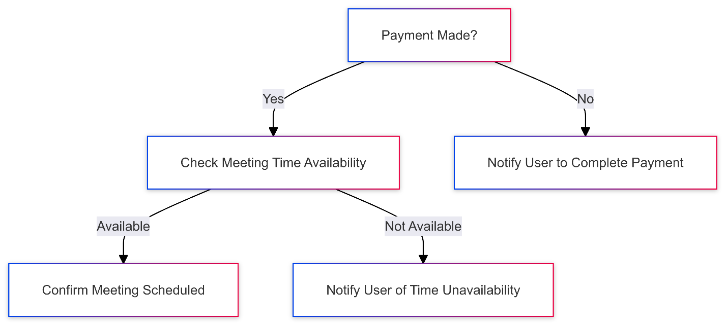

## Career Path Selection Decision Tree

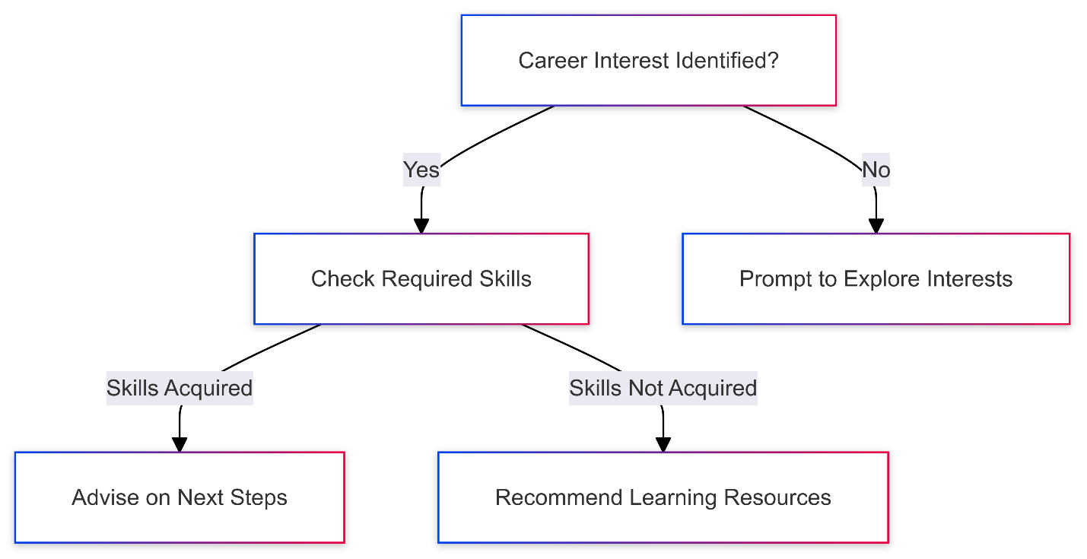

## Feedback Submission Decision Tree

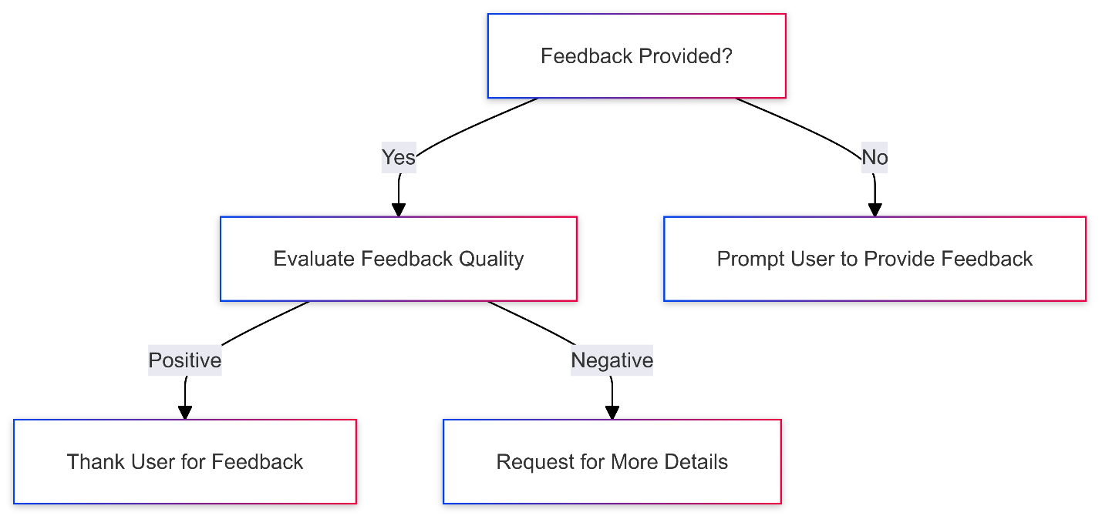

# Use Cases

## User Login Use Case Diagram

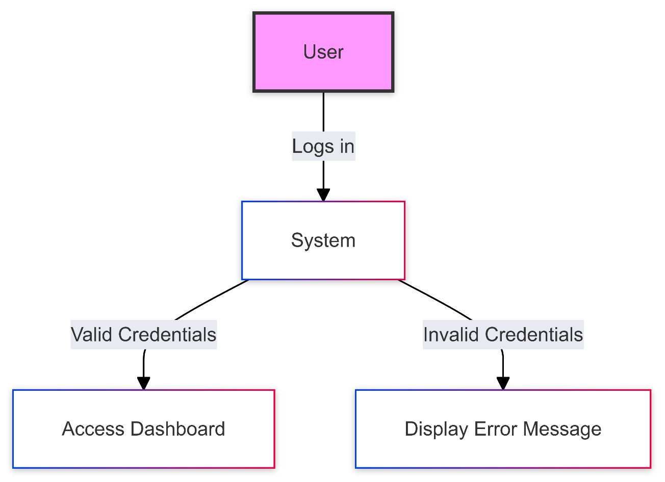

## Career Recommendation Generation Use Case Diagram

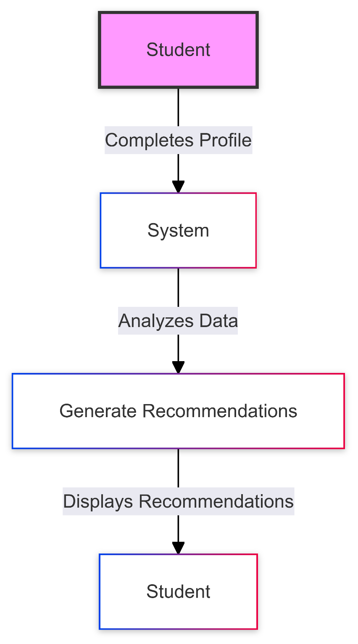

## Meeting Scheduling Use Case Diagram

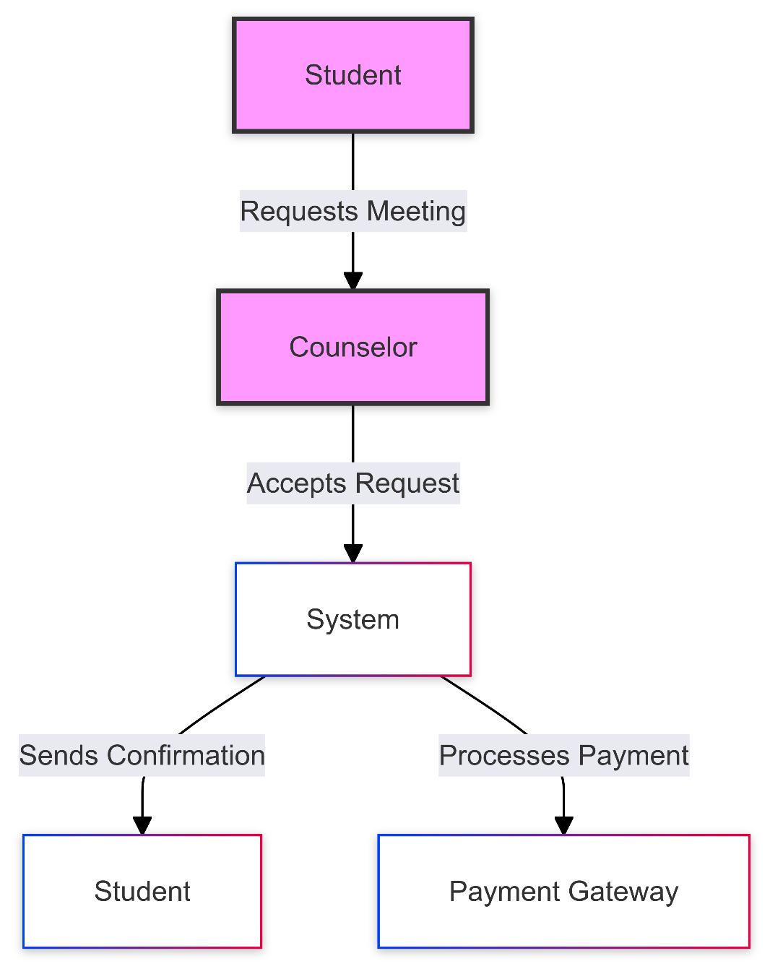

## Feedback Submission Use Case Diagram

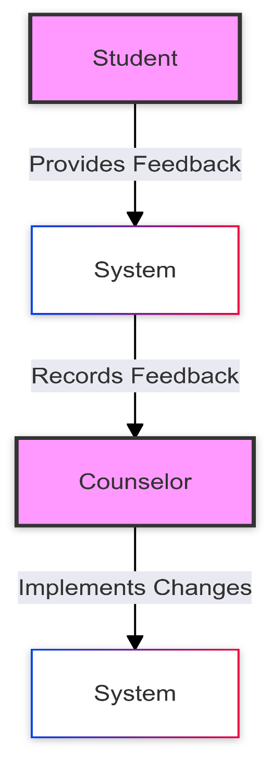

# https://cms.boardmix.com/images/articles/what-is-a-conceptual-architecture-diagram.pngConceptual Design

